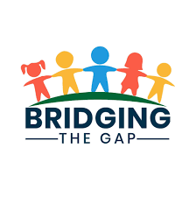
Client Name:__________________________________ Client Phone Number:___________________

Date of Birth:_____________Client Address:______________________________________________

List all members of household with date of birth:
Name: | Relationship | DOB
Current annual income:____________ Are you currently employed & where:____________________
Do you share the residence with another wage earner?________________________________
Briefly explain your need for this service and any extenuating circumstances we should know:

_________________________________________________________________________________

_________________________________________________________________________________

Referring Agency:_____________________Case Manager & Phone #_________________________

Items Needed: Number of Beds:_____Twin Bedding:__________
(No cribs or crib mattresses are available)
If other household furniture or items are available, what is immediately needed:
_________________________________________________________________________________

_________________________________________________________________________________
Guidelines and Rules of the Program
Clients must present a need of furniture for themselves or dependent children. Priority will go to children first if limited supply is available.
Referred clients may be denied if they have utilized the program previously.
Clients must need an item and not just want an item
Clients are not guaranteed the items listed in their referral
We reserve the right to refuse service to any client referred to our program based on client’s lack of cooperation or poor attitude.
If a client misses an appointment with us (or you aren’t there when they deliver the furniture), without notice, the referral will be denied.
If a client fails to return 2 phone calls they will be placed on the denial list. Please update us with a change in phone number.
I understand that most items received from Bridging the Gap were used before being donated. I agree to receive all items “AS IS.” I AGREE TO HOLD Fort Dodge Community Foundation and United Way, it’s volunteers, agents and donors, harmless from liability for an injury that could arise from use of items received from Bridging the Gap.

Client Signature:____________________________________ Date:________________________

