BEST BOOKS TO READ

Ages 0-2
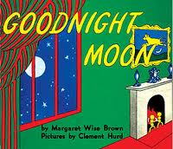
- Goodnight Moon, by Margaret Wise Brown
- The Very Hungry Caterpillar by Eric Carle
- Press Here by Herve Tullet
- Five Little Ducks by Raffi
- Love You Forever by Robert N. Munsch
- Brown Bear, Brown Bear, What Do You See? By Bill Martin Jr.
- Mama Bird, Baby Birds by Angela Johnson
- Max’s Bedtime by Rosemary Wells
- Gossie by Olivier Dunrea
- The Neighborhood Mother Goose by Nina Crews
- Clap Hands by Helen Oxenbury
- My First Counting Book by Lilian Moore
- Green by Laura Vaccaro Seeger
- Go Away, Big Green Monster! By Ed Emberley
- How the Zebra Got Its Stripes by Justine Fontes
- The Night Before Christmas by Clement C. Moore

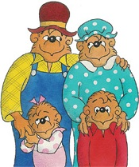
Ages 3-5
- The Berenstain Bears series by Stan Berenstain
- Little Critter series by Mercer Mayer
- Corduroy by Don Freeman
- Brown Bear, Brown Bear, What Do You See? By Eric Carle and Bill Martin, Jr.
- Llama Llama, Red Pajama by Anna Dewdney
- If You Give a Mouse a Cookie by Laura Numeroff
- The Story of Ferdinand by Munro Leaf
- The Monster at the End of this Book by Jon Stone
- Biscuit by Alyssa Satin Capucilli
- Guess How Much I Love You by Sam McBratney
- Green Eggs and Ham by Dr. Seuss
- Where the Wild Things Are by Maurice Sendak
- The Very Hungry Caterpillar by Eric Carle
- Little Bear by Else Holmelund Minarik
- Harold and the Purple Crayon by Crockett Johnson
- Chrysanthemum by Kevin Henkes
- Doorbell Rang by Lois Ehlert
- Go Away, Big Green Monster! By Ed Emberley
- The Tale of Peter Rabbit by Beatrix Potter
- The Rainbow Fish by Marcus Pfister Herbert
- The Great Fuzz Frenzy by Janet Stevens and Susan Stevens Crummel

Ages 6-8
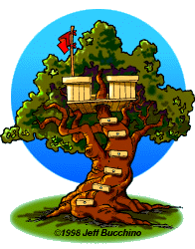
- Magic Tree House series by Mary Pope Osborne
- Junie B. Jones series by Barbara Park
- Berenstain Bears series by Stan Berenstain
- Little Critter series by Mercer Mayer
- My Father’s Dragon series by Ruth Stiles Gannet
- Hank Zipzer series by Henry Winkler and Lin Oliver
- Diary of a Wimpy Kid series by Jeff Kinney
- Ramona Quimby series by Beverly Cleary
- Boxcar Children series by Gertrude Chandler Warner
- Sideways Stories from Wayside School by Louis Sachar
- The Best Seat in Second Grade by Katharine Kenah
- The Great Fuzz Frenzy by Janet Stevens and Susan Stevens Crummel
- Matilda by Roald Dahl
- If You Give a Mouse a Cookie by Laura Numeroff
- The Dot by Peter H. Reynolds
- Ish by Peter H. Reynolds
- The Giving Tree by Shel Silverstein
- Amber Brown Is Not a Crayon by Paula Danziger
- Horton Hears a Who! By Dr. Seuss
- The SOS File by Betsy Byars, Laurie Myers, Betsy Duffey, and Arthur Howard
- The Twits by Roald Dahl

Ages 9-12
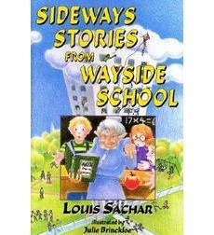
- Sideways Stories from Wayside School by Louis Sachar
- The Lightning Thief (Percy Jackson series) by Rick Riordan
- Harry Potter series by J.K. Rowling
- Maniac Magee by Jerry Spinelli
- Loser by Jerry Spinelli
- Schooled by Gordon Korman
- The Phantom Tollbooth by Norton Juster
- The City of Ember by Jeanne DuPrau
- The Callahan Cousins series by Elizabeth Doyle Carey
- Shiloh by Phyllis Reynolds Naylor
- Hank Zipzer series by Henry Winkler and Lin Oliver
- Diary of a Wimpy Kid series by Jeff Kinney
- Holes by Louis Sachar
- Frindle by Andrew Clements
- The Landry News by Andrew Clements
- The Twits by Roald Dahl
- Stormbreaker (Alex Rider series) by Anthony Horowitz
- Are You There, God? It’s Me, Margaret by Judy Blume
- The Mouse and the Motorcycle by Beverly Cleary
- Dear Mr. Henshaw by Beverly Cleary
- Ella Enchanted by Gail Carson Levine
- The Westing Game by Ellen Raskin
- Ramona Quimby series by Beverly Cleary

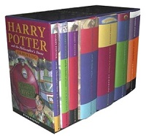
Teens
- Harry Potter series by J.K. Rowling
- The Hunger Games series by Suzanne Collins
- Tiger’s Curse series by Colleen Houck
- Stormbreaker (Alex Rider series) by Anthony Horowitz
- Matched series by Ally Condie
- The Book Thief by Markus Zusak
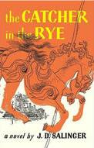
- The Maze Runner by James Dashner
- Uglies series by Scott Westerfeld
- Gone series by Michael Grant
- The Maximum Ride series by James Patterson

Classic Books
- Call of the Wild, by Jack London
- To Kill a Mockingbird, by Harper Lee
- Cry, the Beloved Country, by Alan Paton
- Tinker, Tailor, Soldier, Spy by John le Carre
- The Red and the Black, by Stendahl
- The Stranger, by Albert Camus
- The Great Gatsby, by F. Scott Fitzgerald
- Robinson Crusoe, by Daniel Defoe
- Little Women, by Louisa May Alcott
- Hamlet, by William Shakespeare
- Macbeth, by William Shakespeare
- Romeo and Juliet, by William Shakespeare
- The Picture of Dorian Gray, by Oscar Wilde
- The Secret Garden, by Frances Hodgson Burnett
- The Odyssey, by Homer
- Diary of a Young Girl, by Anne Frank
- The Good Earth, by Pearl S. Buck
- The Little Prince, by Antoine de Saint-Exupery
- The Divine Comedy, by Dante Aligieri

- A Tale of Two Cities, by Charles Dickens
- A Christmas Carol, by Charles Dickens
- Great Expectations, by Charles Dickens
- Red Badge of Courage, by Stephen Crane
- The Grapes of Wrath, by John Steinbeck
- Gone With the Wind, by Margaret Mitchell
- A Farewell to Arms, by Ernest Hemingway
- The Old Man and the Sea, by Ernest Hemingway
- Siddhartha, by Herman Hesse
- 1984, by George Orwell
- Brave New World, by Aldous Huxley
- Animal Farm, by George Orwell
- Pride and Prejudice, by Jane Austen
- Sense and Sensibility, by Jane Austen
- Jane Eyre, by Charlotte Bronte
- Treasure Island, by Robert Louis Stevenson
- The Count of Monte Cristo, by Alexander Dumas
- Catcher in the Rye, by J.D. Salinger
- War and Peace, by Leo Tolstoy
- The Hobbitt, by J.R.R. Tolkien
- Anna Karenina, by Leo Tolstoy
- Crime and Punishment, by Fyodor Dostoevsky
- Catch 22, by Joseph Heller
- Wuthering Heights, by Emily Bronte
- Tom Sawyer, by Mark Twain
- Huckleberry Finn, by Mark Twain
- Atlas Shrugged, by Ayn Rand
- Les Miserables, by Victor Hugo
- The Scarlet Letter, by Nathaniel Hawthorne

